ASSIGNMENT #1:
NumPy & Pandas Documentation

NumPy:

- Installing NumPy with pip after installing pip and python:

python -m pip install --user numpy

- Importing NumPy:

import numpy as np

- Creating arrays:

””” creating a homogeneous multidimensional array with NumPy ”””

arr_a = np.array([[1,2], [3,4]])

print(arr_a)

[[1 2]
[3 4]]

#printing out the type of an array
print(type(arr_a))

<class 'numpy.ndarray'>

””” create an array of specific dimension and type of value”””

# 4-dimensional array of integer type
arr_b = np.array([[1,2], [3,4], [5,6], [7,8]])

print(arr_b.ndim)

4

””” creating a one-dimensional array filled with single default float type of value zero”””

arr_c = np.zeros(1)

print(arr_c)

[0.]

””” creating a two-dimensional array filled with default float type values of one”””

arr_d = np.ones((2,3))

print(arr_d)

[[1. 1. 1.]
[1. 1. 1.]]

””” creating a multidimensional array by filled with a series of specified value e.g. 3”””

arr_e = np.full((2,4), 3)

print(arr_e)

[[3 3 3 3]
[3 3 3 3]]

creating 3x3 array (3 by 3 array) of random number values”””

arr_f = np.random.random((3,3))

print(arr_f)

[[0.60627721 0.23339283 0.08339032]
[0.67946766 0.5872377 0.385604 ]
[0.00425911 0.25245944 0.28708964]]

”””creating a one-dimensional array using the arange method: arrange(start index, ending index, step size)”””

arr_g = np.arange(0, 10, 2)

print(arr_g)

[0 2 4 6 8 ]

- Indexing

””” accessing specific indexes/elements/components multidimensional arrays”””

arr_a = np.array([[1,2], [3,4], [5,6]])

””” accessing the first row of a multidimensional array”””

print(arr_a[0])

[1,2]

””” accessing the second row of a multidimensional array”””

print(arr_a[1])

[3 4]

””” accessing the last row of a multidimensional array”””

print(arr_a[-1])

[5 6]
””” accessing a specified indexed column e.g. 2 for all rows of a multidimensional array”””

print(arr_a[:,1])

[2 4 6]

””” accessing the first element/column value of the second row of a multidimensional array”””

print(arr_a[1,0])

3

””” accessing the last element/column value of the last row of a multidimensional array”””

print(arr_a[-1,-1])

6

””” accessing a slice of an array for specified columns of all rows using the start index: end position: and skip value e.g. 3:10:2”””

row_1 = [1, 2, 3, 4, 5, 6, 7, 8, 9, 10]
row_2 = [11, 12, 13, 14, 15, 16, 17, 18, 19, 20]
row_3 = [21, 22, 23, 24, 25, 26, 27, 28, 29, 30]

arr_b = np.array([row_1, row_2, row_3])

#slice
print(arr_b[:,3:9:2])

[[4 6 8]
[14 16 18]
[24 26 28]]

””” accessing a slice of an array for specified columns of specified rows using the start index: end position: and skip value e.g. -3:-9:-2”””

#slice using negative indexes
print(arr_b[2,-3:-9:-2])

[28 26 24]

#Mixing it up: various positive and negative array indexes & splice start: end : and skip values.
print(arr_b[1], arr_b[2,-3:-9:-2])

[11 12 13 14 15 16 17 18 19 20] [28 26 24]

print(arr_b[0,4:9], arr_b[2,-3:-9:-2])

[5 6 7 8 9] [28 26 24]

print(arr_b[1,6:9],arr_b[2,-3:-9:-2])

[17 18 19] [28 26 24]
””” creating an array of Boolean type values based on a specified condition e.g. arr_b > 8 evaluated on the values of an existing array”””

#Boolean indexing
greater_than_8 = arr_b > 8

print(greater_than_8)

[[False False False False False False False False True True]
[True True True True True True True True True True]
[True True True True True True True True True True]]

print(arr_b[greater_than_8])

[ 9 10 11 12 13 14 15 16 17 18 19 20 21 22 23 24 25 26 27 28 29 30]

print((arr_b[greater_than_8])[1:len((arr_b[greater_than_8])):5])

[10 15 20 25 30]
print((arr_b[:, 0:5:2]))
[[ 1 3 5]
[11 13 15]
[21 23 25]]
print((arr_b[2:, 0:5:2]))
[[21 23 25]]

#Using the where method
drop_under8_array = np.where(arr_b > 8, arr_b, 0)
print(drop_under8_array)

[[ 0 0 0 0 0 0 0 0 9 10]
[11 12 13 14 15 16 17 18 19 20]
[21 22 23 24 25 26 27 28 29 30]]

print(np.where(greater_than_8 == False, 0, arr_b))

[[ 0 0 0 0 0 0 0 0 9 10]
[11 12 13 14 15 16 17 18 19 20]
[21 22 23 24 25 26 27 28 29 30]]

print(np.where(arr_b > 8, arr_b*2, -3))
[[-3 -3 -3 -3 -3 -3 -3 -3 18 20]
[22 24 26 28 30 32 34 36 38 40]
[42 44 46 48 50 52 54 56 58 60]]

#Using the logical_and method
drop_10_and_under_and_21_and_over = np.logical_and(arr_b>10, arr_b<21)

print(Drop_10_and_under_and_21_and_over)

[[False False False False False False False False False False]
[ True True True True True True True True True True]
[False False False False False False False False False False]]

print(arr_b[drop_10_and_under_and_21_and_over])

[11 12 13 14 15 16 17 18 19 20]

- Reshaping and Transforming:

”””determining the size of an array i.e. the total number of elements = number of rows x number of columns”””

arr_a = np.array([[1,2], [3,4]])

print(arr_a.size)

4

”””determining the dimensions of an array using shape”””

print(arr_a.shape)

(2,2)

”””reshaping an array to different dimensions of the same size”””

arr_x = arr_a.reshape(4,1)

print(arr_x)

[[1]
[2]
[3]
[4]]

”””Transposing a multidimensional array”””

arr_y = arr_a.T

print(arr_y)

[[1 3]
[2 4]]

”””Transposing an array that has already been transposed once returns the original array”””

print(arr_y.T)

[[1 2]
[3 4]]

- Dtype:

”””NumPy types”””

# np.int16 Integer (-32768 to 32767)
# np.int32 Integer (-21474683648 to 21474683647)
# np.int64 Integer (-9223372036854775808 to 9223372036854775807)

# np.uint16 Integer (0 to 65535)
# np.uint32 Integer (0 to 4294967295)
# np.uint64 Integer (0 to 18446744073709551615)

#np.float Same as Python’s float

”””creating an array of values with default type without specifying the dtype”””

arr_a = np.array([32766, 32767, 32768])

print(arr_a.dtype)

int32

”””creating an array of values with specified data type using dtype”””

arr_a = np.array([32766, 32767, 32768], dtype=np.int64)

print(arr_a.dtype)

int64

”””creating an array of values with specified data type using dtype”””

arr_a = np.array([32766, 32767, 32768], dtype=np.float)

print(arr_a.dtype)

float64

”””creating an array of values with specified data type using dtype”””

arr_a = np.array([32766, 32767, 32768], dtype=np.int16)

print(arr_a.dtype)

int16

#Array element is greater than maximum value for int16 data type causing an overflow, so the value of that element becomes a negative value.
print(arr_a)

[32766 32767 -32768]

”””creating an array of values with an unsigned data type using dtype”””

arr_a = np.array([-1, 0, 1], dtype=np.uint16)
print(arr_a.dtype)

uint16

#Array has a negative value whereas the specified datatype is unsigned i.e. made up of 0 and positive integers only, so the negative figure becomes a positive figure.
print(arr_a)

[65535 0 1]

- Array Math:

arr_a = np.array([[1,2], [3,4]])
arr_b = np.array([[3,3], [5,5]])
arr_c = np.array([[2,4], [6,8]])

”””single array math operations”””

#summing all values in an array
print(arr_a.sum())

10

#summing all values along the 0 axis i.e. columns
print(arr_a.sum(axis = 0))

[4 6]

#summing all values along the 1 axis i.e. rows
print(arr_a.sum(axis = 1))

[3 7]

#finding the cumulative sum of all values in an array
print(arr_a.cumsum())

[ 1 3 6 10]

#finding the cumulative sum of all values in the columns of an array
print(arr_a.cumsum(axis = 0))

[[1 2]
[4 6]]

#finding the cumulative sum of all values in the rows of an array
print(arr_a.cumsum(axis = 1))

[[1 3]
[3 7]]

#multiplying all values in an array
print(arr_a.prod())

24

#finding the cumulative product of all values in an array print(arr_a.cumprod())

[ 1 2 6 24]

#finding the peak-to-peak sum of all values in an array print(arr_a.ptp())

3

#finding the peak-to-peak sum of axis 1, along row values in an array print(arr_a.ptp(axis = 1))

[1 1]

#finding the minimum value in an array
print(arr_a.min())

1

#finding the minimum value along all rows an array
print(arr_a.min(axis = 1))

[1 3]

#finding the maximum value in an array
print(arr_a.max())

4

#finding the maximum value along all columns in an array
print(arr_a.max(axis = 0))

[3 4]

#finding the mean of values in an array
print(arr_a.mean())

2.5

”””two array math operations”””

#summing the corresponding values of two arrays with same size
print(arr_a + arr_b)

[[4 5]
[8 9]]

#subtracting values of one array from corresponding values of another array
print(arr_a - arr_b)

[[-2 -1]
[-2 -1]]

#multiplying the corresponding values of two arrays
print(arr_a * arr_b)

[[3 6]
[15 20]]
#dividing the values of one array by corresponding values of another array
print(arr_a / arr_b)

[[0.33333333 0.66666667]
[0.6 0.8 ]]

#Rasing values of one array to the power of corresponding values of another array with same shape
print(np.power(arr_a, arr_b))

[[ 1 8]
[ 243 1024]]

”””three (or more) array math operations”””
#summing the corresponding values of three arrays with same size
print(arr_a + arr_b + arr_c)

[[ 6 9]
[14 17]]

#dividing the corresponding values of one array by a second array and dividing that output by the corresponding values of a third array
print(arr_a / arr_b / arr_c)

[[0.16666667 0.16666667]
[0.1 0.1 ]]

- Broadcasting:

arr_a = np.array([[1,1,1], [2,2,2], [3,3,3]])
arr_b = np.array([[0,1,2]])
arr_c = np.array([[1], [2], [3]])

”””NumPy broadcasting allows us to perform operations on compatible arrays: dimensions that can be matched, despite the differences in shape or the original arrays”””

#summing the corresponding values of two arrays of different shape, but compatible dimensions
print(arr_a + arr_b)

[[1 2 3]
[2 3 4]
[3 4 5]]

#summing the corresponding values of three arrays of different shapes, but compatible dimensions
print(arr_a + arr_b + arr_c)

[[2 3 4]
[4 5 6]
[6 7 8]]

#summing the corresponding values of two arrays of different shapes, but compatible dimensions
print(arr_a + arr_c)

[[2 2 2]
[4 4 4]
[6 6 6]]
Pandas:
- Installing Pandas with pip

pip install pandas

- Importing Pandas:

import pandas as pd

- Creating Series:

from pandas import Series
”””Working with Series”””
#Creating and printing an empty series
ser = Series()

print(ser)

Series([], dtype: float64)

print(type(ser))

<class 'pandas.core.series.Series'>

#Creating and printing a series with values in a list
ser1 = Series([1,2,3,4])

print(ser1)

0 1
1 2
2 3
3 4
dtype: int64

#printing all values in a series including repeated values
ser2 = pd.Series(list(“adbbbaacdcddabc”))

print(ser2)
0 a
1 d
2 b
3 b
4 b
5 a
6 a
7 c
8 d
9 c
10 d
11 d
12 a
13 b
14 c
dtype: object

#using the unique() method to output the unique values in a series without repetitions
print(ser2.unique())

['a' 'd' 'b' 'c']

#using the value_counts() method to output the number of times each value in a series is repeated
print(ser2.value_counts())

b 4
a 4
d 4
c 3
dtype: int64

- Creating a DataFrame:

from pandas import DataFrame
”””Creating DataFrames using a list, Series, NumPy array, copied data or csv file”””
data = [1,2,3,4,5]

print(type(data))

<class 'list'>

#Creating a DataFrame from a python list
df0 = DataFrame(data)

print(df0)

0
0 1
1 2
2 3
3 4
4 5

print(type(df0))

<class 'pandas.core.frame.DataFrame'>

#Creating a DataFrame from a series
df0 = DataFrame(ser1)

print(df0)

0
0 1
1 2
2 3
3 4

print(type(df0))

<class 'pandas.core.frame.DataFrame'>

#Using NumPy arrays to create a DataFrame
arr_1 = np.array([[2,np.nan,3], [4,5,np.nan]])

print(arr_1)

[[ 2. nan 3.]
[ 4. 5. nan]]
df1 = DataFrame(arr_1, index=[0,1], columns=list("ABC"))
print(df1)
A B C
0 2.0 NaN 3.0
- 4.0 5.0 NaN

#Using head(n) to output the first n rows in DataFrame
print(df1.head(1))

A B C
0 2.0 NaN 3.0

#Using tail(n) to output the last n rows in DataFrame
print(df1.tail(1))

A B C
- 4.0 5.0 NaN

#sum up DataFrame values along the columns
print(df1.sum())

A 6.0
B 5.0
C 3.0
dtype: float64

#sum up DataFrame values along the row
print(df1.sum(axis = 1))

0 5.0
1 9.0
dtype: float64

#Find the minimum DataFrame value
print(df1.min())

A 2.0
B 5.0
C 3.0
dtype: float64

#Find the maximum DataFrame value
print(df1.max())

A 4.0
B 5.0
C 3.0
dtype: float64

#Output the standard statistics of the DataFrame
print(df1.describe())

A B C
count 2.000000 1.0 1.0
mean 3.000000 5.0 3.0
std 1.414214 NaN NaN
min 2.000000 5.0 3.0
25% 2.500000 5.0 3.0
50% 3.000000 5.0 3.0
75% 3.500000 5.0 3.0
max 4.000000 5.0 3.0

#creating a DataFrame from copied tables data using read_clipoard() method
countries_population_df = pd.read_clipboard()

print(countries_population_df)

# Country (or dependency) World Share
0 1 China 18.47 %
1 2 India 17.70 %
2 3 United States 4.25 %
3 4 Indonesia 3.51 %

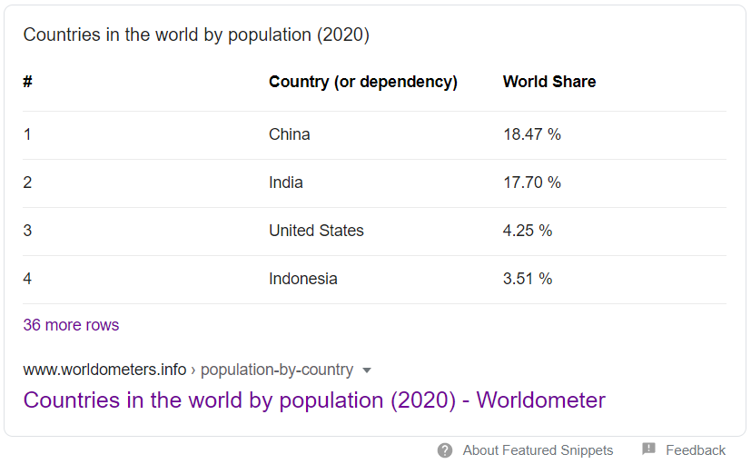
Fig1: Data copied from the web to create countries_population_df DataFrame above

#printing the columns of the DataFrame
print(countries_population_df.columns)
Index(['#', 'Country (or dependency)', 'World Share'], dtype='object')

#printing the data in a specified column of the DataFrame
print(countries_population_df['World Share'])

0 18.47 %
1 17.70 %
2 4.25 %
3 3.51 %
Name: World Share, dtype: object

#adding a new column Fertility Rate to the DataFrame
countries_population_df2 = DataFrame(countries_population_df,columns=['#', 'Country (or dependency)', 'World Share', 'Fertility Rate']

#specifying the data/list of values in the new column Fertility Rate co lumn of the DataFrame with an NumPy array
countries_population_df2['Fertility Rate'] = np.array([1.7, 2.2, 1.8, 2.3])

print(countries_population_df2)

Country (or dependency) World Share Fertility Rate
0 China 18.47 % 1.7
1 India 17.70 % 2.2
2 United States 4.25 % 1.8
3 Indonesia 3.51 % 2.3

#creating a DataFrame from a csv file
df2 = pd.read_csv('class_records.csv')

Name Gender Major
0 C. Nicole F Mathematics
1 A. Smith M Geography
2 R. Jackson M Psychology
3 W. Brown F History
4 S. Simons M French

Visualizing data with matplotlib:
- Installing Pandas with pip:

import matplotlib.pyplot as plt

- Plotting Graphs:

”””plotting the values in a DataFrame”””

#creating a DataFrame from random number generated using Numpy
df3 = pd.DataFrame(np.random.randn(12).reshape(3,4), index=[0,1,2],columns=list("ABCD"))print(df3)
print(df3)
A B C D
0 0.782448 -0.451563 0.336148 0.590079
1 -0.631219 -0.470011 -1.475325 0.070030
- 0.984146 -0.702963 -0.230451 0.943594

#Using the matplotlib.pylot to plot out the DataFrame’s graph

plt.plot(df3)
plt.legend(df3.columns,loc="lower right")
plt.savefig('sampleplot.png')
plt.show()

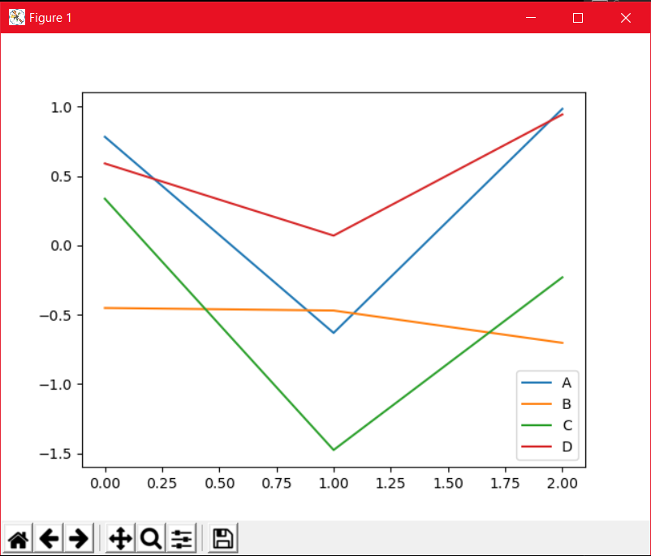
Fig2: Graph plotted for DataFrame df3 above

